TScore


Installation Guide
This document includes features introduced at TScore v11.3

TScore the complete Trampoline Competition package
TScore is a registered trademark

Contents

1 Introduction 2
2 Installation and First Use 3
2.1 Computer Requirements: 3
2.1.1 The TScore application 3
2.1.2 The TScore database 3
2.1.3 The TScore Tablet Apps 3
2.2 Concepts 4
2.3 Installation Sequence 5
2.4 PostgreSQL Database Installation 5
2.4.1 PostgreSQL SERVER Installation - Scripted 5
2.4.2 PostgreSQL SERVER Installation 6
2.5 TScore Installation 9
2.6 Creating Your First Competition 10
3 Installing the TScore Android Apps 12
4 QIRA Integration Web Service 14
5 Help! 14

Introduction
Welcome to the TScore Installation Guide. This manual will help you install and configure the various TScore components, including the PostgreSQL database, the main TScore and VScore Windows applications, the TScore-QIRA integration service and the various Android scoring apps.

Throughout this manual there are useful hints, indicated with a ‘light bulb’ symbol: | 
and the occasional bit of technobabble to keep us anoraks happy, indicated thus: | 
Some of the screen shots in this manual may be slightly different from your version – you should still recognise them though. If all else fails, just try a few things in the program – it is very forgiving and should let you know if you are about to break anything!

Installation and First Use

Computer Requirements:

The TScore application
TScore is designed to run on Windows PCs and is now only formally supported on Windows 10 and 11.
Pretty well any PC built since 2010 should cope with it. Current development and testing is all on Windows 11. We will try to help if you have to run it on an older version of Windows, but it is no longer explicitly tested on those versions. TScore should also be able to be run on Windows Server versions, but it is not tested on these at present.

IMPORTANT!
You must have a copy of Excel installed on your PC for many of the features; in particular, entry processing, timetabling and exporting. Development testing uses Office 365, Office 2019 and Office 2016, although older versions should still work.
To print Certificates you will need Word. Compatibility has been very high historically with hardly any problems reported. Occasionally a new Excel function may be used in some TScore templates that may not work with very old versions, but workarounds are generally possible
To send emails you will need Outlook. This feature has been tested with Outlook 2007, 2010, 2019, 2024 and 365. Some changes to your security settings in Outlook may be necessary to allow programmatic control.
Most of the computers at a competition will not need MS Office, unless they are printing or exporting results. Cheap copies of older Office versions can be obtained on eBay or other recyclers!

The TScore database
TScore’s competition data is stored in a PostgreSQL relational database. The PostgreSQL server can by run on either Windows or Linux (or even MacOS if you wish).
Given that Windows 10/11 has an inbound connection limit of 20, if you intend using a significant number of Android tablets for judges, you could hit that limit. The app does disconnect within a few seconds of reading or writing to the database, but we strongly advise against relying on this.
Instead, the cheapest solution is to use a Linux server for the PostgreSQL database. TScore itself will not run on Linux, but that isn’t a problem – Linux computers present to a mixed network as just another machine.
TScore has been used extensively in this configuration against PostgreSQL running on Linux Mint v17 and more recently Mint v22. Ubuntu has also been used successfully. Performance and reliability are excellent.

The TScore Tablet Apps
The TScore solution includes multiple judge’s apps that run on Android devices. These include the Execution & HD Judge App (T-Judge), the difficulty app (D-Judge) and an artistic gymnastics app for BSGA floor (G-Judge).
Most Android devices manufactured since 2016 should be fine – Android version 6 (‘Marshmallow’ – API v23) is the oldest version supported. It has been used very successfully with Amazon Fire tablets in particular. The Android apps are available as APK file downloads from the TScore website.

Concepts
TScore uses a SQL database server to record the entrants and scores for all of your competitions. Each competition is created in its own named database.
It is important to note however, that there is not necessarily a separate file on the server for each of these. To backup or copy a competition you must therefore use the 'Export' option to produce a file, then 'Import' it to another TScore system. Importing and Exporting the database can only be performed on computers that have the database server software installed, even if the database itself is on a remote computer.
TScore uses a PostgreSQL database, which is freely available and requires no additional licensing.
It is best to use the version that has been tested with TScore although others may work. Installing the database tends to be the most complex part of the setup unfortunately, but if you get stuck, we can run a remote online support session to fix most problems. TScore will automatically check for versions from 8 to 18, although v16 is currently the minimum recommended.

Scoring updates the database server directly when you click the 'Save' button for each competitor. When you start scoring a competitor, their current scores are read from the database.

There is currently no record locking, as the same competitor is not expected to be bouncing on more than one panel at the same time. This does mean that if two computers should attempt to record scores for the same competitor at the same time, the values entered by the last one will overwrite the values of the first one, (as you would expect).

Competition entry forms are in Excel format and designed to be simple to use. Unfortunately, this means that they are quite complex internally, as age groups and other clever picklists need a few cunning expressions to make them work smoothly for the person filling them in. For this reason, the worksheets are ‘locked’ for those parts that should require no changes. The password for locked sheets is 'barani' – but we recommend that you re-lock the sheets before sending them out to avoid people accidentally breaking them.
Competition documents are produced in Excel format - this includes the timetable, programme, checklists and results.
The presentation of Checklists and Results can be changed by altering their associated Excel templates. This means that you can change colours, column widths, images, text fonts and sizes if you feel so inclined. You must however preserve the rows and columns as they are defined in the templates.
At most competitions more than one computer is used to record scores – one per panel is normal. The computers are therefore networked together so they can share a single database in which all of the results are recorded. TScore just needs a TCP/IP connection to communicate with its database. Since a true database server is employed, network failures should not cause any more than a temporary interruption, rather than the database locking and corruption problems prevalent in other products that rely on file sharing to operate.

Installation Sequence
The recommended sequence of installations is:
- PostgreSQL Server
- TScore / VScore (combined installer)
- Tablet Apps

PostgreSQL Database Installation
You must install the PostgreSQL Server program on your ‘master’ database server. It is advisable to install it on client computers for us in case of network hardware failure.
If you are using a Linux server for the master database, you must still install the same release version of PostgreSQL on at least one of your Windows PCs so that TScore has access to the database utilities needed to manage competitions. (e.g. Import/Export/Rename/Delete/Archive ).
IMPORTANT FOR INSTALLING POSTGRESQL on Windows:
The current TScore PostgreSQL installer includes a simple command file to make this a ‘hands-free’ installation. You are strongly urged to use that for consistency.
However, if you choose to install PostgreSQL manually, you MUST install PostgreSQL to a folder other than one in “C:\Program Files” or your desktop. See the separate document on ‘Troubleshooting PostgreSQL’ for details.
We recommend creating a folder called 'C:\Postgres' for the sake of consistency.
TScore should work with most versions of PostgreSQL, but testing is currently performed primarily on version 18. We recommend this version, so the installation screens below relate to that.
If you run mixed versions on different computers, you may get errors reported when exporting / imports between different versions.

PostgreSQL SERVER Installation - Scripted
When you download the PostgreSQL installer from the TScore website, it is delivered as a single ZIP file.
You must create a safe location to unzip this (we recommend putting all of the TScore and PostgreSQL installation files into a C:\TScore folder). You must unzip the files first to install the software – do not run the installer from within the zip file!
When unzipped, you will see that the folder includes a ReadMe text file, and the main Install-Postgres.bat file.
To install, simply run click to run the .bat file as administrator. The installation should then proceed without needing further input from you.

PostgreSQL SERVER Installation
If you really want to install the database in a more custom manner, you will need to run the  postgresql-18.3-2-windows-x64.exe file directly  You may see this installer first – this is needed to install some Microsoft runtime components. | 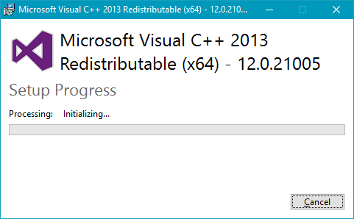  Then you see the actual PostgreSQL installer:  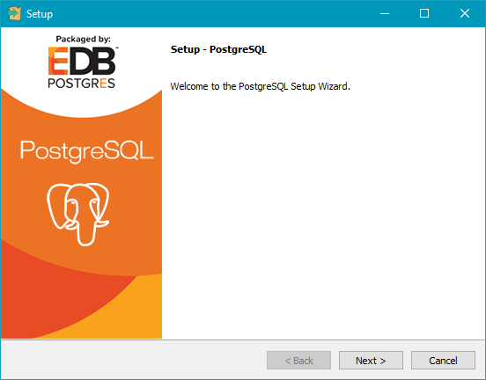  Click Next
1 | 2
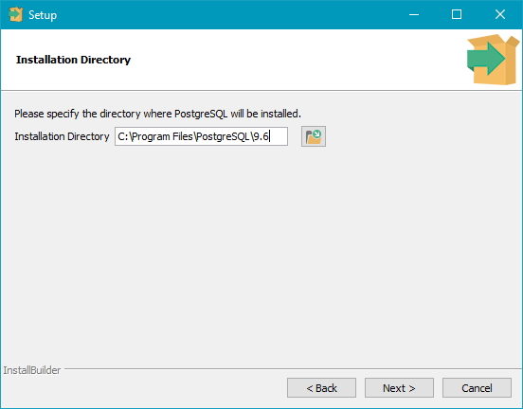  Choose the directory to install the database program.  Do NOT to use the default location set in the installer. Use a folder somewhere other than in “Program Files”. We suggest C:\Postgres (or another drive).  Click Next | 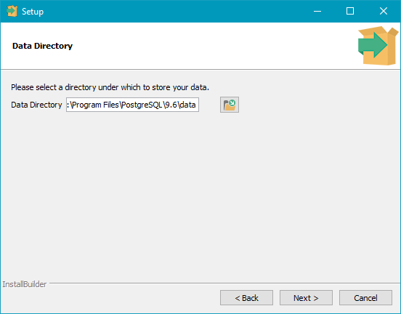  Set the location for the competition data files. These are best in a folder below your installation folder.  Click Next
3
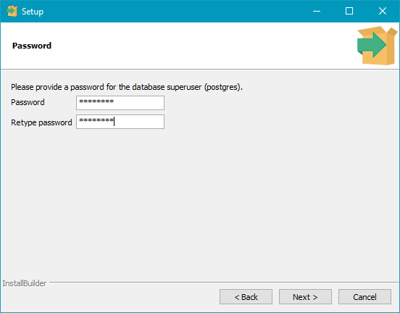 | Use postgres as the password  (You can use others, but will then have to configure the setting in TScore when you run that). .  Click Next
4 | 5
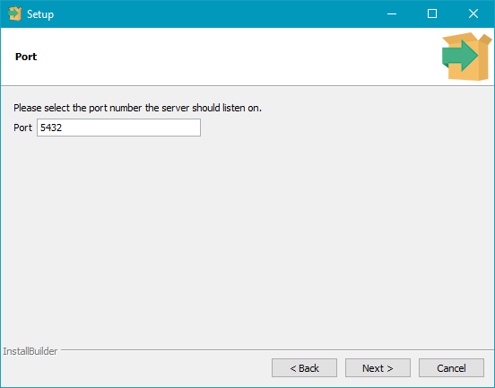  Leave this at the default value – 5432 | 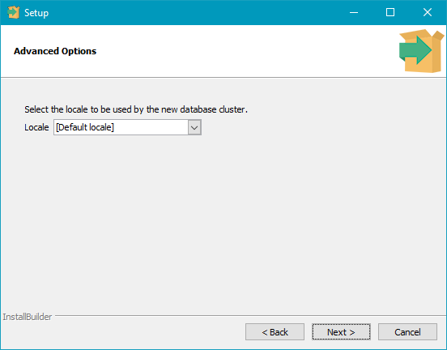  Leave this at the default
6 | 7
 | 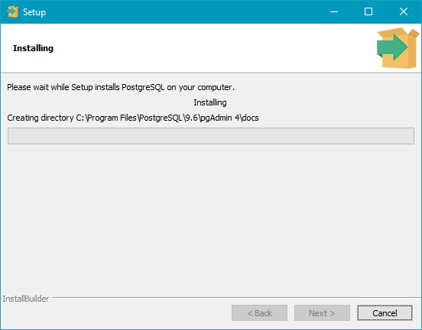
8
During installation, you may get warnings from your firewall (screens will vary depending on what firewall you have installed). You must allow network access for the Postgres services (port 5432).

9
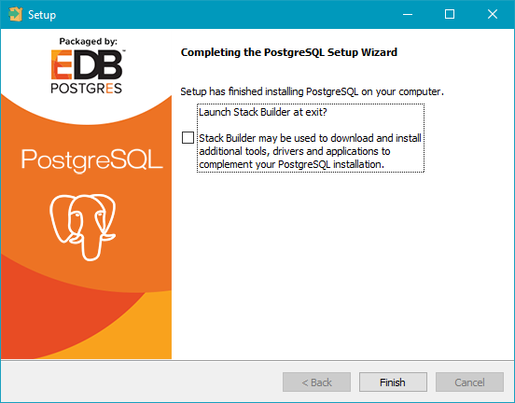 | UNCHECK ‘Launch Stack Builder’ and click Finish  (You don't need any of the additional tools it offers)

TScore Installation
Installing TScore should be simple – just run ‘setup.exe’ and follow the instructions on screen. However, you will have to install a database before you can use TScore – see the PostgreSQL installation section later in this document for information on this.
Here are the screens you’ll see during installation.

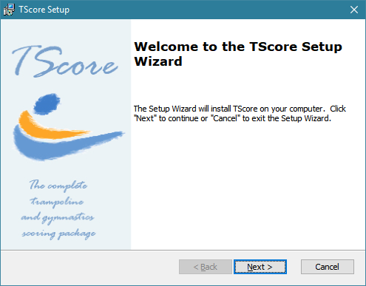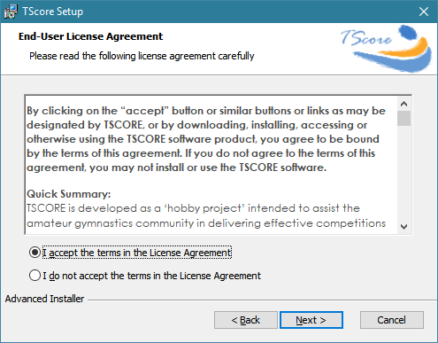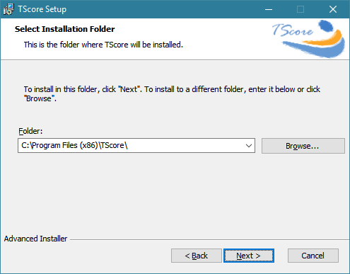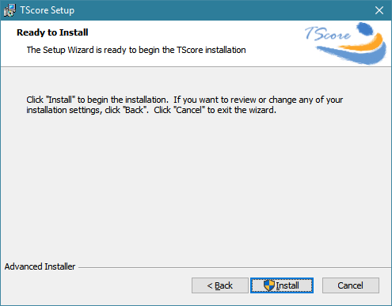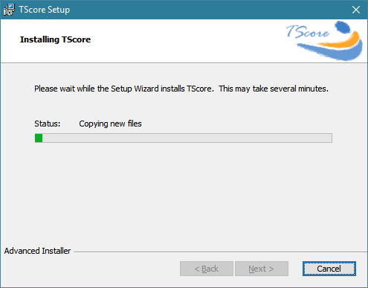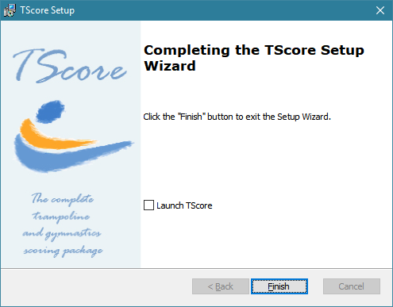

Creating Your First Competition

The very first time you run TScore, there are a couple of steps you need to go through to set it up. The following sequence assumes that you have got Excel installed on your computer, as it is needed to process the entry forms.
If this is not the case though, you can still use TScore with some restrictions on entry form processing and printing / exporting results.

Run TScore by picking the TScore option from the Start Menu or desktop icon:

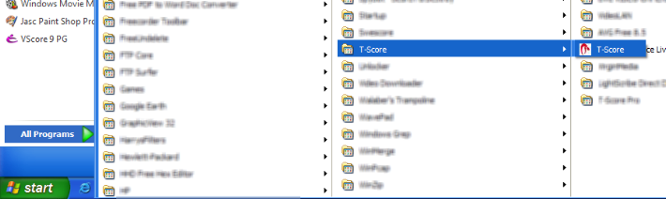

1. The main screen will display with the current Server and Database shown as ‘Not Set’:  2. Click the ‘Choose Database’ button at the top of the screen to set the database server name. | 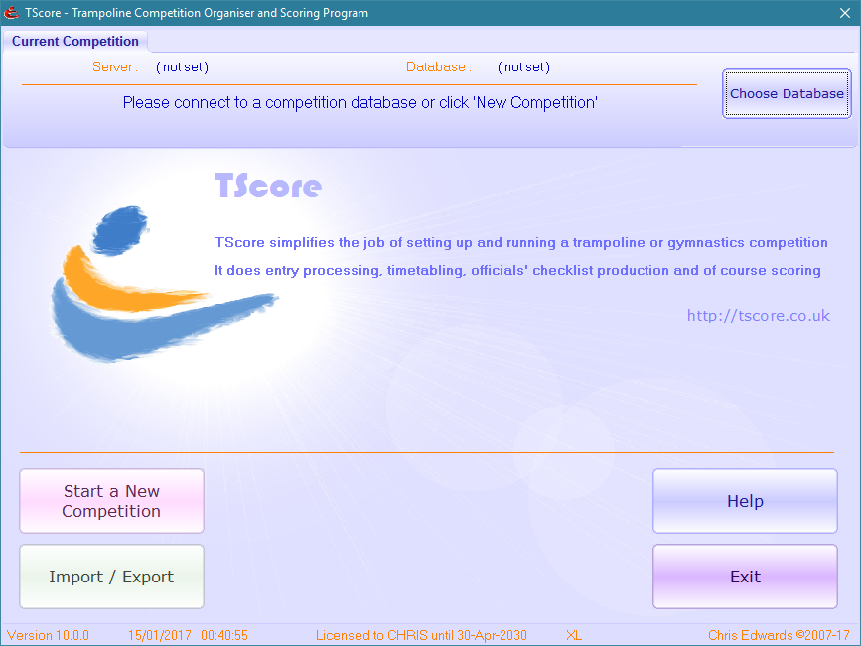

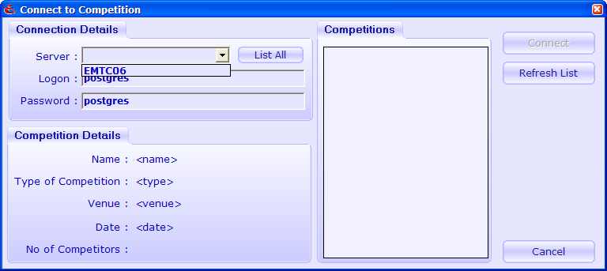 | 3. Pull down the list of servers.  4. Pick the one you want to use (normally your local machine if this is the first installation). If you can’t see yours, try typing in ‘127.0.0.1’
TScore tries to list databases on the chosen server. If there aren't any, it will offer to install some demonstration competitions for you. This is the best way to go!
5. Click Yes and then wait for a minute while the demo databases are installed
6. Now pick one of the competitions to explore what TScore can do
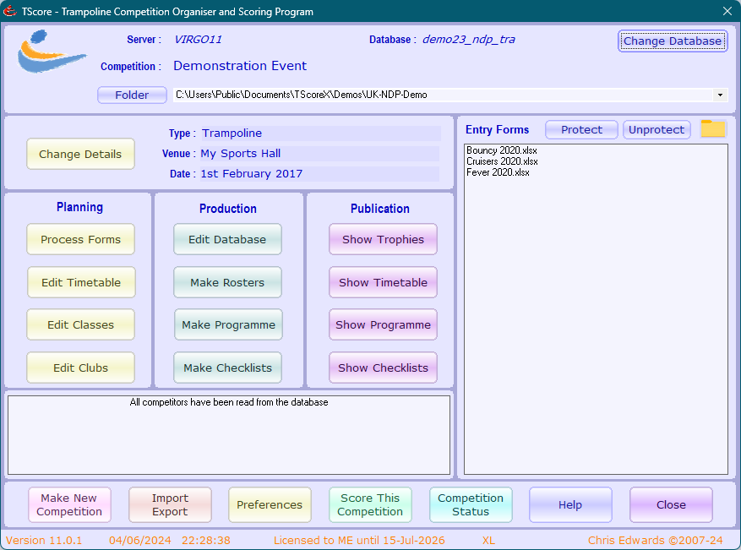 | You are now in the ‘Edit Competition’ screen, with the Entries folder set to the sample provided with TScore.  You can now just explore the various scoring and configuration options.  7. Click the ‘Process Entries’ button to see how entry processing is done.

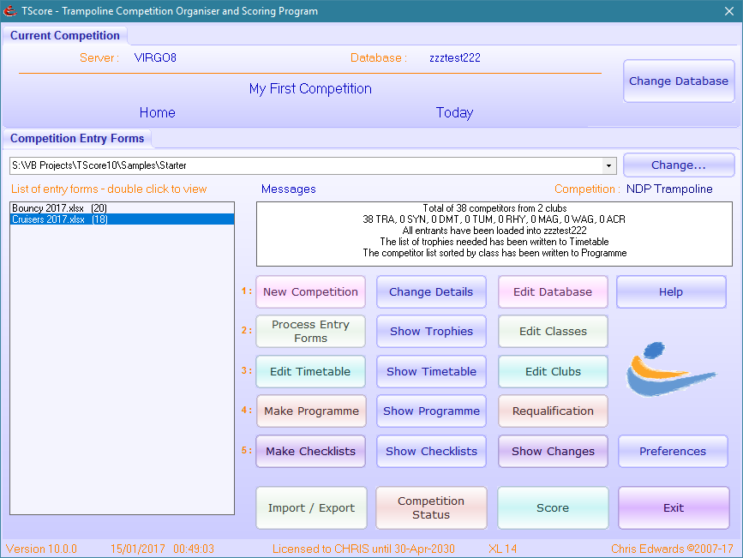

Installing the TScore Android Apps
There are currently 3 TScore Android Apps that you may choose to use at your events. These are:
T-Judge (For Execution and HD judges, covering Trampoline, DMT and Tumbling)
D-Judge (For Difficulty judges at Trampoline, DMT and Tumbling)
G-Judge (For BSGA Floor Gymnastics judges)
You can install any combination of these on your tablets. Only one should be run at one time on a given tablet though.
The TScore Apps are not currently published in the Google Play Store, so they must be installed directly onto your phone or tablet. This should be a simple exercise.
On your Android device use the browser to navigate to the TScore website ‘Downloads’ page and click the link for the app(s) that you want to install. It should offer you the option of installing the app (it will ask you to confirm because you are downloading from somewhere other than the Google Play store). Be assured that TScore contains no adware or nasty surprises!
Here are some more detailed instructions to help you out.
Google Play Store Devices
Most Android devices are set up to use Google Play Store. However, the TScore app is not yet published on the store. You should proceed as follows.
On your Android device (phone or tablet) use the browser to navigate to the download page and click the App download link. It should offer you the option of installing the app (it will ask you to confirm because you are downloading from somewhere other than the Google Play store). Android will offer to scan the app for you, which is of course always advisable.
In an ideal world that just works. However, some browsers and older versions of Android make life a little harder. You may find that instead of downloading the app as an ‘apk’ file, instead it lists as a txt file. To get round this, you need to install the Google Chrome browser from PlayStore or Amazon store. Then navigate to this page using Chrome, and the download should appear correctly as an apk file.
You might now be able to run the apk file directly to install it. Sometimes though, you cannot! In this case, you should download an Android File Manager app from the Play store. (e.g. “FileManager”). With this app, navigate to the Downloads folder and click on the apk file from there. It should now install. You may need to rename the file to restore the necessary ‘.apk’ extension.
Amazon Fire Devices
Fire tablets are great quality but constrained to the Amazon App Store rather than the much bigger Google Play Store.
On your Fire tablet, click Settings, then Security and Privacy. Find the ‘Apps from Unknown Sources’ switch and enable it. (if you forget to do this, it will prompt you for it later anyway on most devices).
Check for the ‘Files’ app on your Fire tablet – recent version have this pre-installed. If not, run the Amazon Appstore app and search for ‘File Explorer’. Install this app.
Use the Amazon ‘Silk’ browser to navigate to the download page and click the App download link. (A menu may pop up – select ‘Download Link’ and wait a few seconds while it downloads).
Now run the ‘File Explorer’ app and click the Downloads folder. You should see the TScore-Judge.apk file in there.
Click on this file and select Open from the menu. You should now be asked whether you want to open the file with the Package Installer. Click ‘Just Once’ and confirm the next screen. TScore should now be installed.
During the installation, Android will ask you to confirm a few times that you really want to install this untrusted app. At the end it may also ask whether to scan the app for malware. This is always a good thing to do and should not raise any issues.
Another option is to download the apk file to your computer, connect the tablet by USB to the computer and simply copy the apk file into the ‘Downloads’ folder. Then tun a File Explorer on your tablet and tap the file to install it.
To date, the app has been run successfully on: Amazon Fire 7″, 8” and 10”, Nexus 10″, Nexus 7″, various Samsung phones, Acer Iconia A10, HonorPad 11” x8A, Lenovo TB-X606F, ZTE Axon 7 mini, and 7″ generic ‘Softwinner A33’ & ‘Softwinner Q88’ Chinese tablets. Of all these, at between £35 and £60, the 7” Amazon Fire tablets offered the best balance of price, performance and build quality at present (especially during their regular ‘30% off‘ sales), but these were discontinued in 2025. The 8” version is still available, but at £99 full price is a bit more expensive. That does appear regularly in sale events at £60 or less.
We have experienced problems with network connection reliability with some cheap tablets such as the ‘Softwinners’. This issue is due to the tablet itself, not TScore, so we strongly advise that you thoroughly test with any ‘bargain’ devices you may find before committing to wholesale purchase. Newer devices (running Android 14 or above) seem to be much better. For example, we have tested the VASOUN 7” Android 14 tablet (£46 Amazon) under competition conditions and found it to be reliable.
When you first run the app, it tries to choose suitable font sizes to maximise the use of the available screen. However, if you have special access settings configured or an especially high/low resolution device, you may need to adjust the text size scale factor from the Configuration Settings screen for an optimal display.
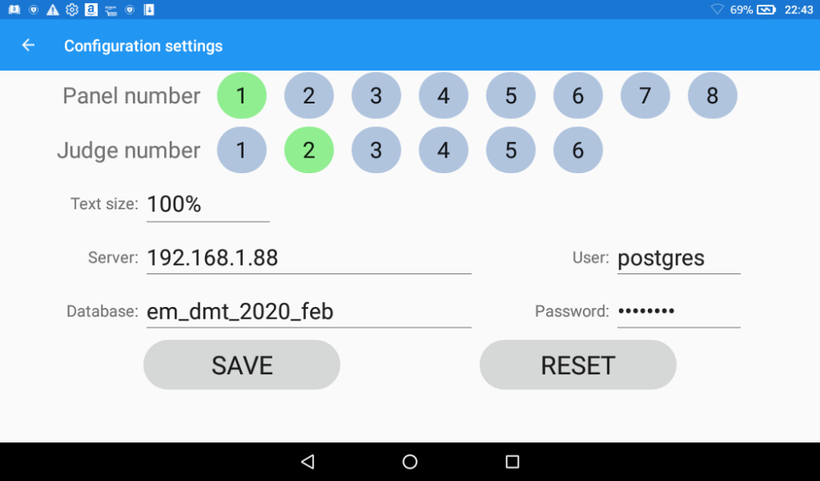

QIRA Integration Web Service
If you have one or more panels with the Eurotramp time-of flight system installed, you can integrate this with TScore by using the TScore-QIRA web service. The service software is installed as part of the main TScore installation. The files for this are placed in C:\Program Files (x86)\TScore\TScore-WebService. No further installation steps are required.
To start the service, just run the TscoreWebService.exe file. You might like to create a link for this on your desktop.
Please see the QIRA Integration Guide for further details.

Help!

If you need any further help or advice, please visit the TScore website http://tscore.co.uk for the latest information and updates.
You may also email support@tscore.co.uk
A TScore User Forum and Knowledge Base are available on the website, and the Facebook TScore User Group is a great way to meet other users and exchange hints, tips and ideas.

Recent Changes
- Major overhaul for TScore Version 11 update

