**Network connection troubleshooting version 2 Dec 2018**

Computer networking problems remain the biggest single issue when setting up. Even if Windows is able to see files on other computers, the communication paths needed by TScore/PostgreSQL may still be blocked.

TScore relies on these Windows network connections to operate, but it is an area where very few people have much knowledge, as setting up free-standing networks is not something you commonly need to do.

I've tried to keep this as simple as possible, but it is a complex topic. Apologies to the networking experts out there for the over-simplification!

Network detection changed in TScore version 10.1.37, so some of the items described in this document may not apply to older versions of the software.

In the following guide, a number of the operations will tell you to run a 'command shell' or 'cmd session'. To do this, go to the windows search and type 'cmd'. You should see the Windows command prompt program offered – just launch that.

|  |  |
| --- | --- |
|  | When it runs, it looks like this: |

So, here is how to get your networks running, and identify some of the Windows configuration options that might break it.

The problems addressed here are those concerned with network communication problems.

Note that if you cannot connect to the database on the *same* computer, you need to fix that problem first! (See a different trouble-shooter for that one!)

So, you have your database running on your 'Server' computer, and can use TScore on that same computer ok. However, when you try to connect from another 'Client' computer, TScore does one of the following:

1. Only lists the server computer when you click the 'List All' button
2. Lists some other computers, but not the one you want
3. Fails to connect to one of the computers that is listed

Each of these can be caused by a number of issues – the following section takes you through the processes for identifying the problem and fixing it.

**Network basics**

Networked computers communicate with each other by each of them having a unique 'IP address'.

These typically are 4 numbers separated by dots – e.g. 192.168.1.27 (there are other formats, but we will stick to these 'version 4' ones for now!)

So, your TScore server may be 192.168.1.10 and your client may be 192.168.1.100

For most home networks, the first two numbers will be 192.168 and the third number must match across all of your computers. (it is possible to have different 3rd digits, but we'll save that for later).

Your computers are normally assigned a unique address by your router (which runs a 'DHCP' service to allocate them). Once a computer has been allocated an address, it usually keeps it, even though that 'lease' has to be renewed every few days.

It is sometimes useful to assign 'Static' IP addresses to computers, which avoids needing a DHCP server. Personally, I find this very helpful as it means I always know the actual address of every one of my computers, without having to keep checking if I have to troubleshoot. It is especially useful to make your TScore database server have a static IP address.

Although the computers communicate by IP address, it is more convenient for us humans to use friendly names for our computers. So, we have a way to lookup an IP address from the name we give the computer. That means we can say 'connect to TSCORE-SERVER' and this gets resolved to 192.168.1.10.

Computers also announce themselves over the network, so you can say 'Please list the computers on my network' for example. There are a number of ways this can be done, but TScore normally uses the simplest Windows mechanism – 'NETBIOS'. However, this may not be enabled by default on your computer.

In addition to the IP address, individual programs can choose a 'port' to communicate through – there are 64000 of these, but you only need to know about one – number 5432, which is the one used by the PostgreSQL database.

**Firewalls**

A firewall is a protective program that can allow or deny access into or out of specific network ports on your computer. By default, port 5432 is not normally allowed, so you will either need to create a 'rule' to allow it, or turn off the firewall for local traffic. More on this later!

**Windows Workgroups**

Windows provides a way of creating your own local network of computers with communication and discovery features – these are 'Workgroups'. You should be using these and ensure that all of your computers are set to the same group, or essential communication paths will be blocked between them. See the section below.

**Network diagnostic strategy**

Given the above, you can see (if you were paying attention) that we can try each part of the communications links one bit at a time to isolate any problems.

The high level strategy that I adopt is as follows:

1. Check the IP addresses of each computer
2. Check that each computer can 'talk' to each of the others
3. Connect the TScore client to the server by giving it the IP address rather than the name
4. Resolve any network communication problems reported when using IP addresses
5. Resolve any database connection problems reported when using IP addresses
6. Investigate and resolve any computer name lookup problems

And here is how you do it.

1. Check the IP addresses of all of your computers
   1. In a cmd shell (see above!) type 'ipconfig'
   2. You should see a list of attributes for each of your network adapters
   3. Try to find the one you are using – wired ones show as 'Ethernet adapter', wireless generally have 'WLAN' in their name
   4. Look for the IPv4 address and note it for each computer
   5. Assuming they are all 192.168.x.y check whether any have different 'x' values
   6. If any are different, look at the 'Subnet Mask' – its 3rd digit must be 0 to allow computers with different 3rd digits to see each other.
2. Check that each computer can see the other
   1. For this we use the 'ping' utility
   2. In the cmd shell, type 'ping <IP Address> as in the example below  
      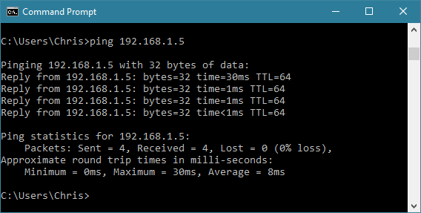
   3. If the computers can communicate, you will see for 'Reply from' lines
   4. If you get timeout or 'no route' errors, verify that the IP addresses are associated with the correct wi-fi adapter; that you have connected to the right access point/router (yes, obvious, but it happens); they are in the same subnet (1st 3 numbers match), and that your (wireless) router is set to allow peer-to-peer connections. (Some routers block this by default).
   5. If you still cannot get them to talk, the firewall may be blocking 'ping'. Very unlikely, but possible. Try temporarily turning off the firewall (see later section) and try again. Do bear in mind though that 'ping' exercises a different network connection type (ICMP) from PostgreSQL (TCP port 5432), so even if you can 'ping' between computers, the database connection could still be blocked by the firewall.
   6. If they still cannot communicate, check that the computers belong to the same WORKGROUP or HOMEGROUP. (Note that HomeGroups use the IPv6 protocol, so it's possible for this to be working while the IPv4 communication is still blocked. HomeGroups frequently seem to expect a live internet connection when you are setting them up, which is not usually the case in a draughty old sports hall. For this reason, I tend to prefer the WORKGROUP mechanism for my networks.) Se the section on setting workgroups for more info.
   7. If that still fails, check whether your computers think they are connected to a Public or Private network. If Public, then communication between computers is heavily restricted. See later section for how to change this.

**Windows Firewall**

The Firewall performs an important safety function – it prevents unwanted connections into and out of your computer (a significant cause of malware and malicious data loss). By default, Windows firewall is enabled and will block access to network ports and programs that it doesn't know about.

These instructions refer to Windows built-in firewall. You may have a 3rd party firewall installed – you will have to follow the instructions provided for that.

To quickly check whether the firewall is causing you trouble, you can simply turn it off on both computers to see if it fixes it. I don't advise doing this while you are connecting to the Internet though – it's there for a reason!

To switch off the Windows 10 firewall (7 and 8 are similar) do the following:

|  |  |
| --- | --- |
|  | Type 'firewall' in the search area, click 'Windows Defender Firewall' |
|  | Now click 'Turn Windows Defender Firewall on or off' |
|  | Then turn the firewall off on both private and public netowkrs (You should only need to do this for Private networks, but Windows 10 has a habit occasionally of classifying EVERY network as 'public' – see later discussion). |
|  | It will of course tell you that you're being naughty, but do it anyway just to check whether this is actually the cause of your trouble.  On this screen you can also see whether Windows thinks your connected network is Public or Private. |

If turning off the firewall fixes the problem, you should then configure the firewall properly!

To do that, on the Firewall screen, click the 'Allow an app or feature through the firewall' option on the left and in the next window, scroll down to 'postgresql' and ensure it is checked.

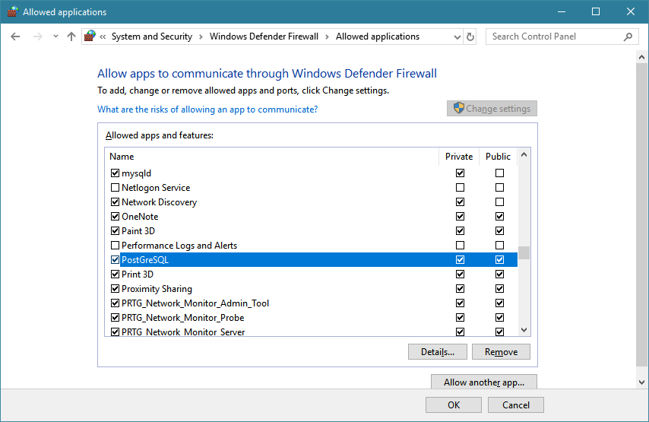

You can also check the 'details..' – the port should be 5432 (assuming you used the defaults from the installer.

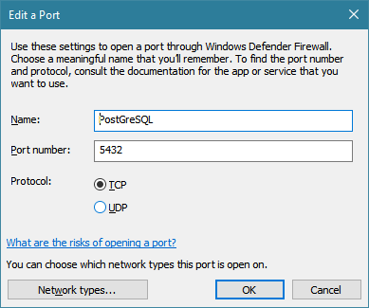

While you are there, check the Network Discovery is also allowed:

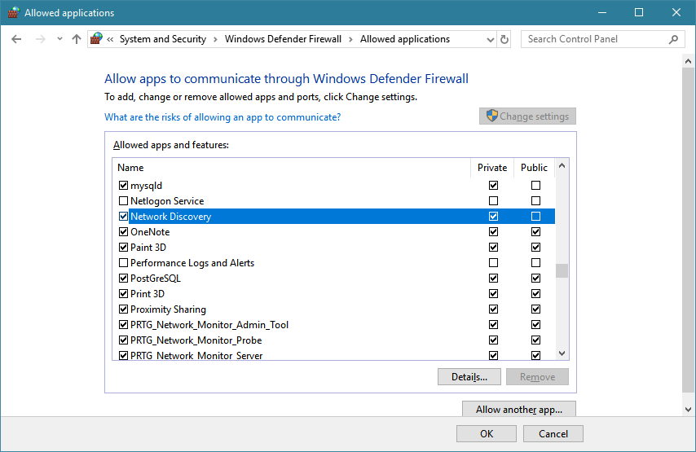

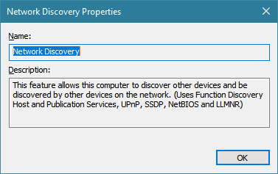

**Windows WorkGroups**

When creating a local area network, Windows works best if you join all of your computers into a 'WorkGroup'. Windows also supports 'HomeGroups' (which adds extra resource sharing features on top of Workgroups, but is not necessary – I've seen it cause more problems in some cases).

To see how your computers WorkGroup is configured, just type 'WorkGroup' in the Windows search:

|  |  |
| --- | --- |
|  | Pick ' Show which workgroup this computer is on' (sic)! |
|  | To change the workgroup, just click the Change Settings link, followed by the Change… button |
|  | You can now change the name of the Workgroup.  **All of your computers must have the same workgroup name.**  If you change it, you will have to reboot for the change to take effect. |

**Public versus Private Network Profiles**Windows classifies each network you are connected to as 'Public' or 'Private'.

If you are on a 'Public' network, it severely restricts communication between computers on that network, as you would expect for security reasons.

To run TScore effectively, it should be on a Private network.

Different versions of Windows have made this variously simple, difficult or downright nearly impossible to change once it has made its mind up! I have even had to resort to changing the registry on some occasions.

Fortunately, recent Windows 10 build (e.g. 1709, which most should have updated to now) makes this fairly easy.

Go to the 'Network And Internet Settings' screen (click on the network tray icon to find this option)

|  |  |
| --- | --- |
|  | Click 'Change Connection Properties' |
|  | ..and you should be able to change to Private. |

For some reason though, certain configurations of Windows 10 do not make it this simple! To fix these cases, you need to run a PowerShell session as administrator.

1. Type 'powershell' in the Windows search area:
2. 
3. Right click the Desktop App entry and select 'run as administrator'.
4. Type the command **Get-NetConnectionProfile**
5. 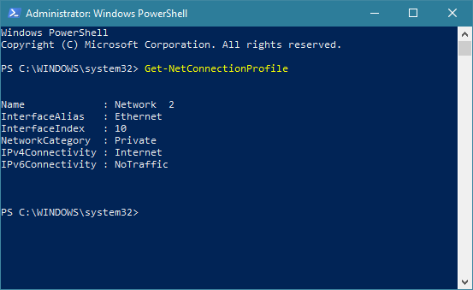
6. If your network is shown as Public, you can change it to Private using:  
    **Set-NetConnectionProfile -NetworkCategory Private**

**Computer Name Resolution**

TScore uses the NETBIOS mechanism to identify computers by name rather than just IP address. This means that you can run your network without having to use a separate Domain Name Service running, or having to use DHCP on your router. This in turn allows it to work with the simplest of peer-to-peer connections.

To achieve this however, you do need to enable NETBIOS names to be passed between computers.

This may mean that you have to change the configuration setting for your network adapter. You can do this as follows.

1. Identify your network adapter (the example here is a Wired Ethernet adapter, but the same principle and interface holds for Wireless adapters).
2.  Click the Network and Internet Settings option from the network tooltray icon, or type 'network' in the search bar.

|  |  |
| --- | --- |
|  | Click 'Change Adapter Options' |
|  | Pick your network adapter, then 'Change Settings of this connection' |
|  | Select Internet protocol Version 4 and click Properties |
|  | This is where you can swap between automatic (DHCP) and fixed IP addresses should you wish.  Click Advanced and then the WINS tab |
|  | Ensure that 'Enable NETBIOS over TCP/IP is selected. Click OK back through the screens to apply the change. |

Until August 2017, this was a very reliable mechanism. The two subsequent Windows 10 updates however have in some cases broken NETBIOS broadcasts. There are still frequent problems with disabled services and start up / timing issues that can make name resolution intermittent.

(For the tecchies, there's a really detailed article here: <https://www.techrepublic.com/article/how-netbios-name-resolution-really-works/>)

Windows utilities will report failures in the underlying services if the 'Master Browser' name server doesn't get picked up by other computers.

Your best chance of success is to always start the database server first, connected to the network, and let it boot up and login completely before starting the other computers.

If you do hit a problem, you can always fall back to connecting by IP address, or create an LMHOSTS file to resolve the names (only really helpful if you have static IP addresses).

There are a few troubleshooting tools that Windows provides, but unless you are a networking expert, it's unlikely they will be of much help. If you are an expert, you will already know about them. (e.g. NBTStat, net view )

Check out these Forum posts too:

<https://tscore.co.uk/wp/forums/topic/database-connection-problems/>

<https://tscore.co.uk/wp/forums/topic/network-problems-with-windows-10-update-1701/>