TScore won't connect to the database!

Every now and again we hit a problem with the PostgreSQL installation that prevents TScore from connecting to the local database. This guide will help you solve these issues.

If you can connect to the local database ok, but are having problems with networked computers, please see the separate troubleshooting guide for networking.

So, here is what you do.

1. Check that the PostgreSQL service is running

Run the windows ‘Services’ application.  Scroll down to find your PostgreSQL service (version numbers may differ):

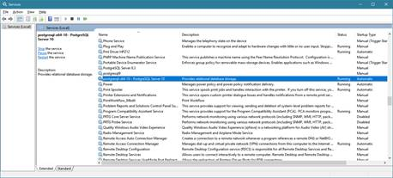

It should show a status of ‘Running’. If not, right click and select ‘Start’.

Normally that is ok, but if there is a configuration or installation problem, you may get an error box displayed.

The normal reason for it not running is an account permissions problem.

Right click and pick ‘Properties’. Then select the Log On tab.

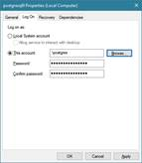

PostgreSQL  8 and 9 typically run as the ‘postgres’ account that you were advised to specify during the installation. Check this is set ok.

You can try swapping this to ‘Local System Account’ – that often fixes the problem.

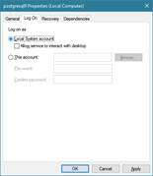

       PostgreSQL 10 will use an account called ‘Network Service’, which is normally fine.

1. If it still fails to start, it may be that you have installed the database server in a location with limited permissions.

Examples include ‘Program Files’ (yes, you’d think this would be ok!) and ‘Desktop’.

In this case, it generally quickest to uninstall it and reinstall in into a simple folder on C: or D:  (I normally set up D:\Postgres  as I have more space there than on C: ).

Note that you must also set the Data folder location similarly – this is actually the one that causes the problems.

(see <https://stackoverflow.com/questions/1251233/unable-to-run-postgresql-as-windows-service> for more info)

Having done that (rebooting the PC if necessary) you should get to the point where the service is running.

1. Now try running TScore on the same computer and connecting.

The server name is normally just the name of the computer you are on, but sometimes the name resolution can fail if certain Windows services aren’t set up properly.

To avoid this, try typing  127.0.0.1  into the Server name box on the connection dialog:

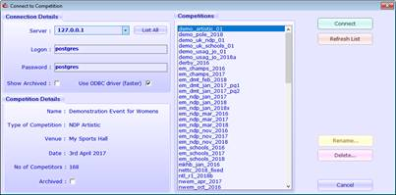

That should be sufficient to get you started.  If it still fails to connect at this stage, check the error message that it returns – best to screenshot that and send it to me!

1. The usual problem at this point is insufficient permissions on one of the PostgreSQL config files,  pg_hba.conf. This file can be found in the PostgreSQL data folder you set during installation.

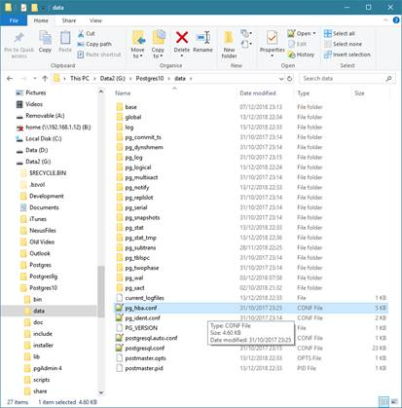

You can edit that file in Notepad (it’s just a text file).

Scroll past the instruction comments to get to the content which is a series of lines like this:

# IPv4 local connections:

host    all             all             127.0.0.1/32            md5

# IPv6 local connections:

host    all             all             ::1/128                 md5

As a first shot, look for entries that have ‘md5’ in them, and change the ‘md5’ to ‘trust’.

TScore normally appends entries to this file for you, but if the program doesn’t have edit permissions on the file, it is unable to write to it.

You can tell if it has done it, as you will see this at the bottom of the file:

##### Automatic network configuration setting added by TScore - 31/10/2017

## Reported PG Error: FATAL:  no pg_hba.conf entry for host "fe80::55e0:fc1a:c777:e516%7", user "postgres", database "postgres", SSL off

host    all         all          fe80::0/64      trust

host    all         all         ::1/128          trust

host    all         all         127.0.0.1/32     trust

host    all         all         192.168.0.0/16   trust

host    all         all         172.16.0.0/12    trust

host    all         all         10.0.0.0/8       trust

If all of this is in place, it really should connect ok.  If not, contact TScore support for advice.

1. When TScore first connects, it will offer to install demo competitions.  These are worth having as examples.
2. So, now that TScore is connecting with the 127.0.0.1 address, it’s worth trying to get the first step of networking operational.

This is where you see whether windows can successfully resolve your computer name.

To do this, open the Connect dialog again and click ‘List All’.  TScore should now search the network for computers and save a lookup list of names and addresses to use.

When it completes (can be a minute or so), your local computer name should be in the list and TScore will try to connect with that.

If that fails, it’s possible that Windows firewall could be blocking the connection.

From here, follow the Network trouble-shooter to resolve local connection issues (firewall mainly if it routes out and back in again).

Once you can connect locally, it’s time to add other computers to your local network.  There’s lots of info about this in the guide.

Specific tips to make things easier – these are all explained in the guide:

Check you can ‘ping’ between computers on your network first

Turn off Windows Firewall on all computers while setting up   
*(turn it on later with the correct ports enabled)*

Ensure your computers belong to the same Windows Workgroup

Ensure your network is identified as ‘Private’

Enable NetBIOS over TCP/IP

Disable IPv6 on the network

Try connecting by IP address (192.168.x.y etc) if names aren’t being found correctly

Beware of computers that have been provided with identical operating system images from your vendor – this can cause networking problems